

MOI HIGH-KABARAK 2025 PREDICTION
Kenya Certificate of Secondary Education
KCSE PREDICTION SERIES 1
233/2 Chemistry (Theory) Paper 2
Time: 2 Hours

NAME…………………………………………………………………………………………
SCHOOL……………………………………………… SIGN…………………………..
INDEX NO……………………………………………. ADM NO………………………

Kenya Certificate of Secondary Education.

INSTRUCTIONS
- Write your name and index number in the spaces provided above.
- Sign and write the date of examination in the spaces provided above.
- Answer all the questions in the spaces provided in the question paper.
- Electronic calculators may be used.
- All working must be clearly shown where necessary.

FOR EXAMINER’S USE ONLY
Question | Maximum Score | Candidate’s score
1 | 12
2 | 12
3 | 10
4 | 11
5 | 12
6 | 14
7 | 09
Total | 80

Answer all the questions
1)a. The diagram below shows a set up for laboratory preparation of chlorine gas. Study it and answer the questions that follow.
Conc.
Hydrochloric Acid

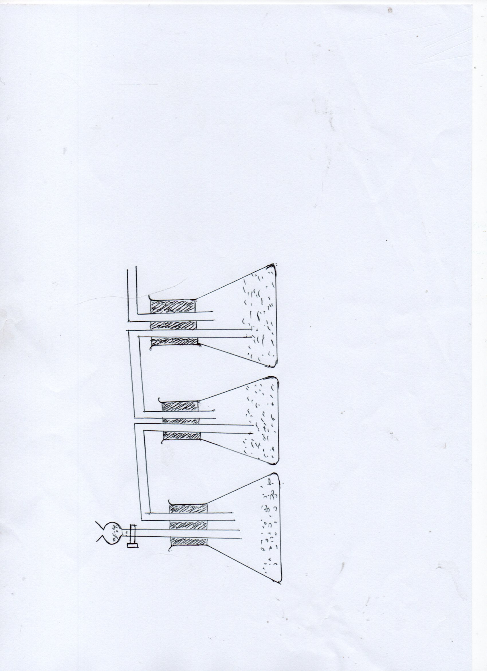
LIQUID J
WATER
SOLID K

- Complete the set up to show how dry chlorine may be collected (1 mk)

- Name Soild K……………………………………………….. (2 mks)
Liquid J………………………………………………

- State and explain the observation made when chlorine gas is bubbled through a solution of potassium iodide (2 mks)
……………………………………………………………….………………………..............
................................................................................................................
................................................................................................................

- Write an ionic equation for the reaction that occurs in iii) above (1 mk)
……………………………………………………………….………………………..................
....................................................................................................................

- Study the flow chart below and answer the questions that follow
Sunlight
Chlorine gas
Gas T
Gas R
Catalyst K
OLEUM
Liquid S
Gas J
Solution Q
Solid M
Gas R
Water

WATER
H₂O

i). Identify the following; Gas R…………………………………………… (2 mks)
Solid M………………………………………….
Gas J……………………………………………..
Liquid S………………………………………….

ii. Write a chemical equation for the formation of gas T (1 mk)
……………………………………………………………….………………………..............
................................................................................................................

iii. Name catalyst K (1 mk)
……………………………………………………………….………………………..............

- State two uses of liquid S (2mks)
……………………………………………………………….………………………..............
................................................................................................................
................................................................................................................

2. The figure below represents a section of the periodic table. Study it and answer the questions that follow. The letters do not represent the actual symbols of elements.
B
C |  |  | D | E |  |  | F | G
 |  | Z
H | J

- i).What chemical family does element J belong to? (1 mk)
……………………………………………………………….………………………..............

ii. Compare the reactivity of element C and H. Explain. (2 mks)
……………………………………………………………….………………………..............
................................................................................................................
................................................................................................................

b) i) Write the chemical formula of the chloride of element D (1 mk)
……………………………………………………………….………………………..............
................................................................................................................

ii) Name the type of structure of the chloride in b(i) above. (1 mk)
……………………………………………………………….………………………..............
................................................................................................................

c). State and explain the difference in atomic radius and ionic radius of element F (2 mks)
……………………………………………………………….………………………..............
……………………………………………………………….………………………..............
................................................................................................................
................................................................................................................

d). Using dots (.) and crosses (x) show how bonding occurs when element E and F react. (1mk)

e). Study the diagram below and answer the questions that follow
TUBE A
WET SAND

ZINC
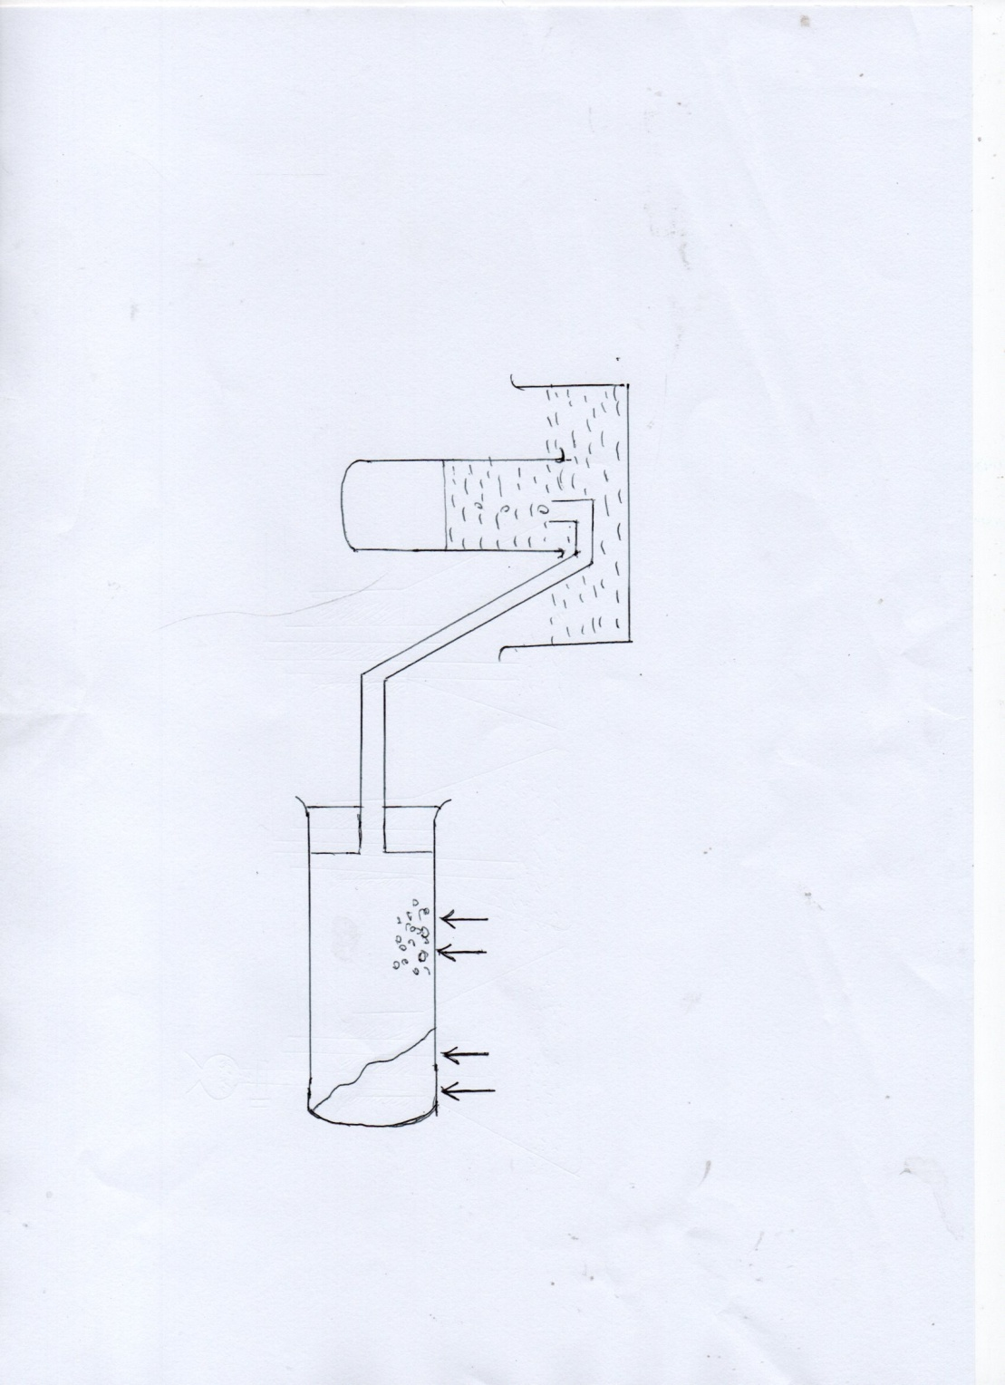
HEAT
HEAT
WATER
GAS X
i. State two observations made in the tube A (2 mks)
……………………………………………………………….………………………..............
................................................................................................................
................................................................................................................

ii. Explain why the sand is heated first before heating the zinc metal (1 mk)
……………………………………………………………….………………………..............
................................................................................................................
................................................................................................................

iii. Give the chemical test of gas X. (1 mk)
……………………………………………………………….………………………..............
................................................................................................................
................................................................................................................

3. a) Name the heat change represented by ΔH in the process represented below.
Na_{(s)} Na _{(g)}ΔH = ⁺ve (1mk)
……………………………………………………………….………………………..............
b) The table below gives some bond energies of some bonds.
Bond | Bond energy (kJ mol )
H – H | 435
Cl – Cl | 243
H – Cl | 431
Calculate the enthalpy changes for the reaction.
H _{2(g)} + Cl_{2(g)} 2 HCl_{(g)} (2mks)

c) i) Define enthalpy of formation of a substance. (1mk)
……………………………………………………………….………………………..............
................................................................................................................
ii) Given that
Calculate the molar heat of combustion of butane ( C₄H₁₀) (2mks)

d) Study the following exothermic reactions involving enthalpy of neutralization
I NaOH_{(s)} + HCl_{(aq)} NaCl_{(aq)} + H₂O_{(l)}ΔH₁
II NaOH_{(aq)} + HCl_{(aq )}NaCl_{(aq)} + H₂O_{(l)}ΔH₂
- Identify the reaction with a higher ΔH value. Giving a reason for your answer. (2mks)
……………………………………………………………….………………………..............
................................................................................................................
................................................................................................................

ii) The atomic numbers of Li and K are 3 and 19 respectively.
Li⁺_{(g)} + _{(aq)} Li⁺_{(aq)}ΔH₃ = ⁻519
K⁺_{(g)} + _{(aq)} K⁺_{(aq)} ΔH₄ = ⁻322
Study the equations above and explain why ΔH₃ is larger than ΔH₄. (2mks)
……………………………………………………………….………………………..............
……………………………………………………………….………………………..............
................................................................................................................
................................................................................................................

4. Use the standard electrode potentials given below to answer the questions that follow.
Ag⁺_{(aq)} + e- Ag_{(s)} + 0.80v……….(i)
Cu²⁺_{(aq)} + 2e- Cu_{(s)} + 0.34v ….…..(ii)
Pb²⁺_{(aq)} + 2e Pb_{(s)} -0.13v…….…(iii)
Zn²⁺_{(aq)} + 2e- Zn(s) -0.76v………(iv)

a) Select two half - cells which when combined will give the lowest e.m.f (1mk)
……………………………………………………………….………………………..............
................................................................................................................

b) Can a solution of silver nitrate be stored in a container of Zinc? (2mks)
……………………………………………………………….………………………..............
................................................................................................................
................................................................................................................
c) An iron jug was electroplated using Chromium. The chromium electrode and iron jug were thoroughly cleaned and weighed before being dipped into the electrolyte. Why was cleaning necessary? (1mk)
……………………………………………………………….………………………..............
................................................................................................................

d) A current of 0.75 Amperes was passed through the solution for one hour and four minutes. The mass of chromium deposited on the jug was 0.52g
(1Faraday = 96500C Cr = 52)
(i) Calculate the quantity of electricity passed. (2mks)

(ii) How many moles in Chromium were deposited? (1mk)
……………………………………………………………….………………………..............
................................................................................................................
................................................................................................................

(iii)Calculate the quantity of electricity in coulombs required to deposit one mole of Chromium. (2mks)

(iv)Deduce the charge of the Chromium ion. (2mks)

5 ) a)An organic compound G whose empirical formula is HCO₂ has molar mass of 90. It reacts with ethanoic in the presence of a few drops of concentrated Sulphuric (VI) acid forming another compound J with a pleasant smell.
(i) Determine the molecular formula of compound G (2marks)
……………………………………………………………….………………………..............
……………………………………………………………….………………………..............
................................................................................................................
................................................................................................................

(ii) To which class of homologous series do compound G and J belong? (2marks)
G: ……………………………………………………………………………………
J: ………………………………………………………………………………………
b) i. What is vulcanization of rubber? (1mk)
……………………………………………………………….………………………..............
................................................................................................................
i). State two properties of vulcanized rubber. (2mks)
……………………………………………………………….………………………..............
................................................................................................................

c) The scheme below shows various reactions and process for some organic compounds.
Study it and answer the questions that follow.
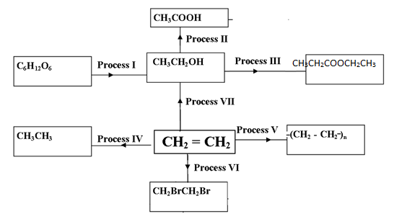

i. Name process I and name any other product formed in the process.
Process I ½ $mk$
……………………………………………………………………………………

Product ½ mk
…………………………………………………………………………………

ii) Name the reagent and condition required in process II.
Reagent ½ $mk$
………………………………………………………………………………………

Condition ½ mk
………………………………………………………………………………………

iii) Name the catalyst and reagent required in step IV.
Catalyst $\frac{1}{2} mk$
………………………………………………………………………………………

Reagent ½ mk
………………………………………………………………………………………

iv) Give any one use of the product formed in process (V) (1mk)
……………………………………………………………….………………………..............
................................................................................................................

v) Name process (VI) (1mk)
……………………………………………………………….………………………..............

6. The flow chart below outlines some of the processes involved in extraction of copper from copper pyrites. Study it and answer the questions that follow.
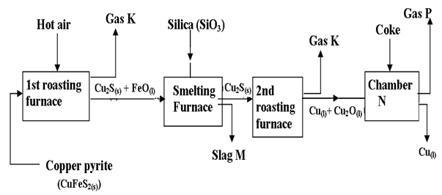
(a)i. Name gas K (1mk)
……………………………………………………………….………………………..............

(ii)Write an equation for the reaction that takes place in the first roasting furnace. (1mk)
……………………………………………………………….………………………..............
(iii) Write the formula for the cation present the slag M. (1mk

................................................................................................................
(iv) Identify gas P. (1mk)
……………………………………………………………….………………………..............

(v)What name is given to the reaction that takes place in chamber N?
Give a reason for your answer. (2mks)
……………………………………………………………….………………………..............
................................................................................................................
................................................................................................................

vi) State two uses of copper metal (2mks)
……………………………………………………………….………………………..............
................................................................................................................

b) Below is a simplified diagram of the Downs cell in which sodium metal is manufactured.
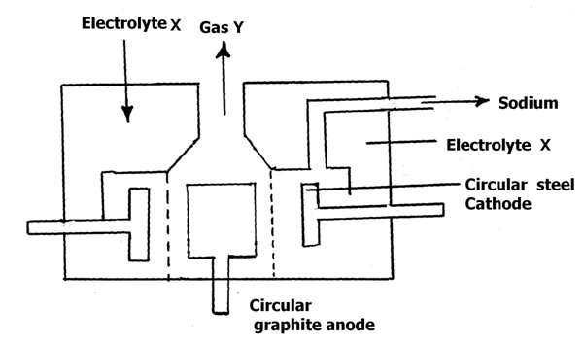
(i) Identify electrolyte X and gas Y. (2mks)
Electrolyte X ………………………………….…Gas Y………………………………

(ii)Give two properties of sodium that make it possible to collect as shown above. (2mks)
……………………………………………………………….………………………..............
................................................................................................................
................................................................................................................

(iii) Why is graphite preferred to steel as the anode? (1mk)
……………………………………………………………….………………………..............
................................................................................................................
................................................................................................................

(iv)Explain how sodium hydroxide pellets would be obtained from sodium amalgam? (1mk)
……………………………………………………………….………………………..............
................................................................................................................
................................................................................................................
END
7) Study the reaction scheme below and answer the questions that follow.
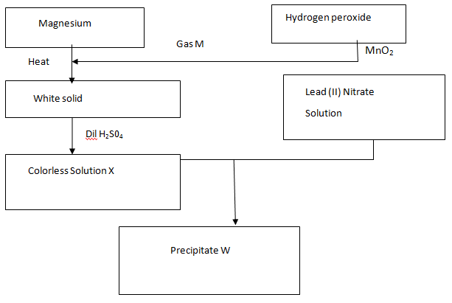
  - Name; Gas M…………………………………………………………….. (1 mk)
Precipitate W……………………………………………………... (1 mk)
b) Write an equation for the formation of ;
The white solid (1 mk)
……………………………………………………………………………………………….
Colorless solution X (1 mk)
……………………………………………………………………………………………….
c) What name is given to the process that produce precipitate W (1 mk)
………………………………………………………………………………………………
d) State two commercial uses of gas M (2 mks)
……………………………………………………………….………………………..............
................................................................................................................

e) If 100cm³ of 0.05M hydrogen peroxide were used to produce gas M. calculate the volume of gas M produced if the hydrogen peroxide decomposed completely.(MGV= 22400cm³) ( 2mks)
……………………………………………………………….………………………..............
................................................................................................................
……………………………………………………………….………………………..............

